**Spark**

**Assignment 1**

**Himanshu Goyal**

**Question 1:**

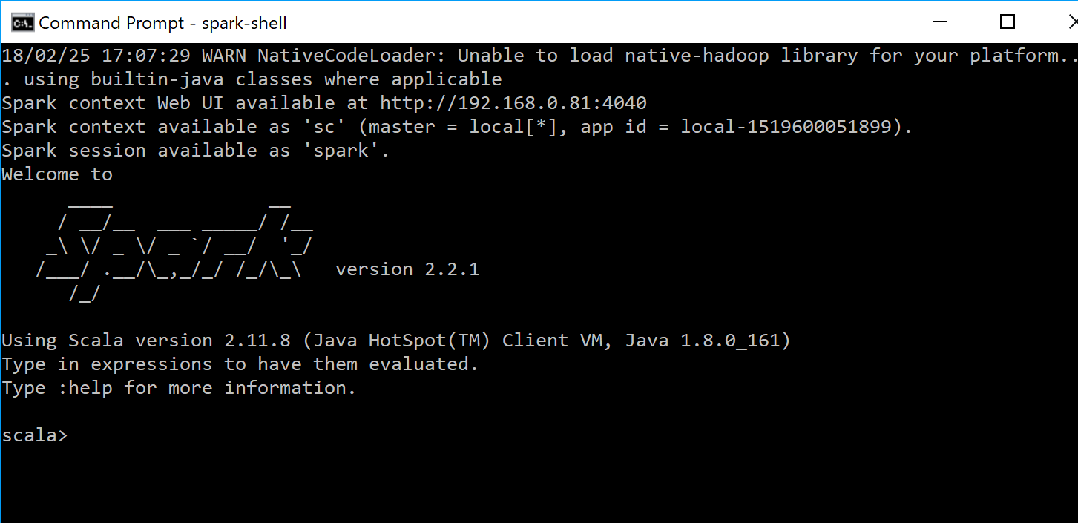

**Question 2:**

Example 1

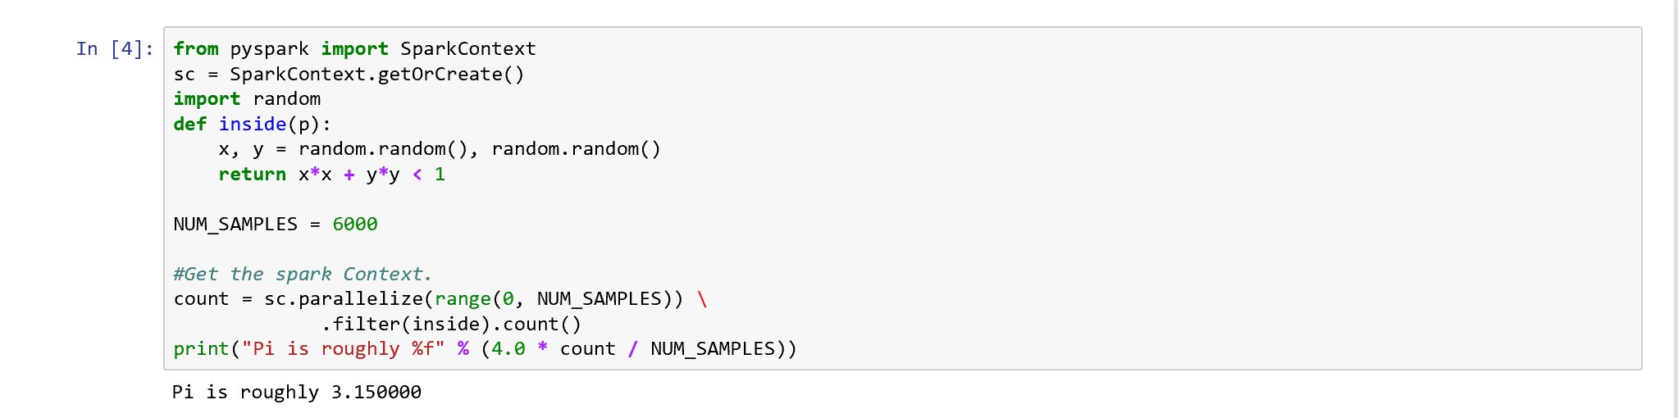

Example 2:

